Orthogonalization

Orthogonalization or orthogonality is a system design property that assures that modifying an instruction or a component of an algorithm will not create or propagate side effects to other components of the system. It becomes easier to verify the algorithms independently from one another, it reduces testing and development time.

When a supervised learning system is design, these are the 4 assumptions that needs to be true and orthogonal.

1. Fit training set well in cost function
   * If it doesn’t fit well, the use of a bigger neural network or switching to a better optimization algorithm might help.
2. Fit development set well on cost function
   * If it doesn’t fit well, regularization or using bigger training set might help.
3. Fit test set well on cost function
   * If it doesn’t fit well, the use of a bigger development set might help
4. Performs well in real world
   * If it doesn’t perform well, the development test set is not set correctly or the cost function is not evaluating the right thing.

Single number evaluation metric

To choose a classifier, a well-defined development set and an evaluation metric speed up the iteration process.

Example : Cat vs Non- cat y = 1, cat image detected

|  |  |  |
| --- | --- | --- |
|  | 1 | 0 |
| 1 | True positive | False positive |
| 0 | False negative | True negative |

Actual class 𝑦



P

redic

t

class

𝑦

ො

# Precision

Of all the images we predicted y=1, what fraction of it have cats?

𝑇𝑟𝑢𝑒 𝑝𝑜𝑠𝑖𝑡𝑖𝑣𝑒 𝑇𝑟𝑢𝑒 𝑝𝑜𝑠𝑖𝑡𝑖𝑣𝑒

Precision (%) = 𝑥 100 = 𝑥 100

𝑁𝑢𝑚𝑏𝑒𝑟 𝑜𝑓 𝑝𝑟𝑒𝑑𝑖𝑐𝑡𝑒𝑑 𝑝𝑜𝑠𝑖𝑡𝑖𝑣𝑒 (𝑇𝑟𝑢𝑒 𝑝𝑜𝑠𝑖𝑡𝑖𝑣𝑒+𝐹𝑎𝑙𝑠𝑒 𝑝𝑜𝑠𝑖𝑡𝑖𝑣𝑒)

# Recall

Of all the images that actually have cats, what fraction of it did we correctly identifying have cats?

𝑇𝑟𝑢𝑒 𝑝𝑜𝑠𝑖𝑡𝑖𝑣𝑒 𝑇𝑟𝑢𝑒 𝑝𝑜𝑠𝑖𝑡𝑖𝑣𝑒

Recall (%) = 𝑥 100 = 𝑥 100

𝑁𝑢𝑚𝑏𝑒𝑟 𝑜𝑓 𝑝𝑟𝑒𝑑𝑖𝑐𝑡𝑒𝑑 𝑎𝑐𝑡𝑢𝑎𝑙𝑙𝑦 𝑝𝑜𝑠𝑖𝑡𝑖𝑣𝑒 (𝑇𝑟𝑢𝑒 𝑝𝑜𝑠𝑖𝑡𝑖𝑣𝑒+𝐹𝑎𝑙𝑠𝑒 𝑛𝑒𝑔𝑎𝑡𝑖𝑣𝑒)

Let’s compare 2 classifiers A and B used to evaluate if there are cat images:

|  |  |  |
| --- | --- | --- |
| Classifier | Precision (p) | Recall (r) |
| A | 95% | 90% |
| B | 98% | 85% |

In this case the evaluation metrics are precision and recall.

For classifier A, there is a 95% chance that there is a cat in the image and a 90% chance that it has correctly detected a cat. Whereas for classifier B there is a 98% chance that there is a cat in the image and a 85% chance that it has correctly detected a cat.

The problem with using precision/recall as the evaluation metric is that you are not sure which one is better since in this case, both of them have a good precision et recall. F1-score, a harmonic mean, combine both precision and recall.

F1-Score=

2

1

+

1

𝑝 𝑟

|  |  |  |  |
| --- | --- | --- | --- |
| Classifier | Precision (p) | Recall (r) | F1-Score |
| A | 95% | 90% | 92.4 % |
| B | 98% | 85% | 91.0% |

Classifier A is a better choice. F1-Score is not the only evaluation metric that can be use, the average, for example, could also be an indicator of which classifier to use.

Satisficing and optimizing metric

There are different metrics to evaluate the performance of a classifier, they are called evaluation matrices. They can be categorized as satisficing and optimizing matrices. It is important to note that these evaluation matrices must be evaluated on a training set, a development set or on the test set.

Example: Cat vs Non-cat

|  |  |  |
| --- | --- | --- |
| Classifier | Accuracy | Running time |
| A | 90% | 80 ms |
| B | 92% | 95 ms |
| C | 95% | 1 500 ms |

In this case, accuracy and running time are the evaluation matrices. Accuracy is the optimizing metric, because you want the classifier to correctly detect a cat image as accurately as possible. The running time which is set to be under 100 ms in this example, is the satisficing metric which mean that the metric has to meet expectation set.

The general rule is:

1 𝑂𝑝𝑡𝑖𝑚𝑖𝑧𝑖𝑛𝑔 𝑚𝑒𝑡𝑟𝑖𝑐

𝑁𝑚𝑒𝑡𝑟𝑖𝑐: { 𝑁𝑚𝑒𝑡𝑟𝑖𝑐 − 1 𝑆𝑎𝑡𝑖𝑠𝑓𝑖𝑐𝑖𝑛𝑔 𝑚𝑒𝑡𝑟𝑖𝑐

Training, development and test distributions

Setting up the training, development and test sets have a huge impact on productivity. It is important to choose the development and test sets from the same distribution and it must be taken randomly from all the data. Guideline

Choose a development set and test set to reflect data you expect to get in the future and consider important to do well.

Size of the development and test sets

# Old way of splitting data

We had smaller data set therefore we had to use a greater percentage of data to develop and test ideas and models.

Or



70

%



30

%



Training set

Test set



2

0

%



Training set



20

%



60

%

Development

set

Test

set

# Modern era – Big data

Now, because a large amount of data is available, we don’t have to compromised as much and can use a greater portion to train the model.



Training set



1

%



98

%

1

%

Development

set

Test

set

# Guidelines

* Set up the size of the test set to give a high confidence in the overall performance of the system.
* Test set helps evaluate the performance of the final classifier which could be less 30% of the whole data set.
* The development set has to be big enough to evaluate different ideas.

When to change development/test sets and metrics

Example: Cat vs Non-cat

A cat classifier tries to find a great amount of cat images to show to cat loving users. The evaluation metric used is a classification error.

|  |  |
| --- | --- |
| Algorithm | Classification error [%] |
| A | 3% |
| B | 5% |

It seems that Algorithm A is better than Algorithm B since there is only a 3% error, however for some reason, Algorithm A is letting through a lot of the pornographic images.

Algorithm B has 5% error thus it classifies fewer images but it doesn't have pornographic images. From a company's point of view, as well as from a user acceptance point of view, Algorithm B is actually a better algorithm. The evaluation metric fails to correctly rank order preferences between algorithms. The evaluation metric or the development set or test set should be changed.

The misclassification error metric can be written as a function as follow:

𝑚𝑑𝑒𝑣

𝐸𝑟𝑟𝑜𝑟  ∑ ℒ{(𝑦̂(𝑖) ≠ 𝑦(𝑖)}

𝑚𝑑𝑒𝑣

𝑖=1

This function counts up the number of misclassified examples.

The problem with this evaluation metric is that it treats pornographic vs non-pornographic images equally. On way to change this evaluation metric is to add the weight term 𝑤(𝑖).

(𝑖) = { 10 1 𝑖𝑓𝑖𝑓 𝑥𝑥((𝑖𝑖)) 𝑖𝑠𝑖𝑠 𝑝𝑜𝑟𝑛𝑜𝑔𝑟𝑎𝑝𝑛𝑜𝑛 − 𝑝𝑜𝑟𝑛𝑜𝑔𝑟𝑎𝑝ℎ𝑖𝑐 ℎ𝑖𝑐

𝑤

The function becomes:

𝑚𝑑𝑒𝑣

𝐸𝑟𝑟𝑜𝑟 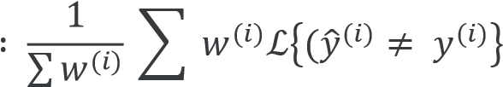

𝑖=1

Guideline

1. Define correctly an evaluation metric that helps better rank order classifiers 2. Optimize the evaluation metric

Why human-level performance?

Today, machine learning algorithms can compete with human-level performance since they are more productive and more feasible in a lot of application. Also, the workflow of designing and building a machine learning system, is much more efficient than before.

Moreover, some of the tasks that humans do are close to ‘’perfection’’, which is why machine learning tries to mimic human-level performance.

The graph below shows the performance of humans and machine learning over time.

The



Bayes optimal

error

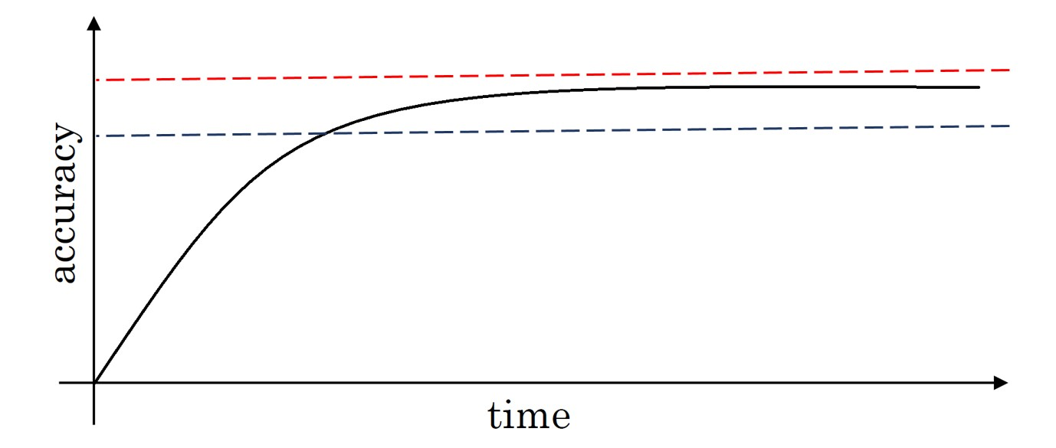

Human

s



Machine

Learning

Machine learning progresses slowly when it surpasses human-level performance. One of the reason is that human-level performance can be close to Bayes optimal error, especially for natural perception problem.

Bayes optimal error is defined as the best possible error. In other words, it means that any functions mapping from x to y can’t surpass a certain level of accuracy.

Also, when the performance of machine learning is worse than the performance of humans, you can improve it with different tools. They are harder to use once its surpasses human-level performance.

These tools are:

* Get labeled data from humans
* Gain insight from manual error analysis: Why did a person get this right?
* Better analysis of bias/variance.
* Avoidable bias
* By knowing what the human-level performance is, it is possible to tell when a training set is performing well or not.
* Example: Cat vs Non-Cat

|  |  |  |
| --- | --- | --- |
|  | Classification error (%) | |
| Scenario A | Scenario B |
| Humans | 1 | 7.5 |
| Training error | 8 | 8 |
| Development error | 10 | 10 |

* In this case, the human level error as a proxy for Bayes error since humans are good to identify images. If you want to improve the performance of the training set but you can’t do better than the Bayes error otherwise the training set is overfitting. By knowing the Bayes error, it is easier to focus on whether bias or variance avoidance tactics will improve the performance of the model.

# Scenario A

* There is a 7% gap between the performance of the training set and the human level error. It means that the algorithm isn’t fitting well with the training set since the target is around 1%. To resolve the issue, we use bias reduction technique such as training a bigger neural network or running the training set longer.

# Scenario B

* The training set is doing good since there is only a 0.5% difference with the human level error. The difference between the training set and the human level error is called avoidable bias. The focus here is to reduce the variance since the difference between the training error and the development error is 2%. To resolve the issue, we use variance reduction technique such as regularization or have a bigger training set.

Understanding human-level performance

Human-level error gives an estimate of Bayes error.

Example 1: Medical image classification

This is an example of a medical image classification in which the input is a radiology image and the output is a diagnosis classification decision.

|  |  |
| --- | --- |
|  | Classification error (%) |
| Typical human | 3.0 |
| Typical doctor | 1.0 |
| Experienced doctor | 0.7 |
| Team of experienced doctors | 0.5 |

The definition of human-level error depends on the purpose of the analysis, in this case, by definition the Bayes error is lower or equal to 0.5%.

Example 2: Error analysis

|  |  |  |  |
| --- | --- | --- | --- |
|  | Classification error (%) | | |
| Scenario A | Scenario B | Scenario C |
| Human (proxy for Bayes error) | 1 | 1 | 0.5 |
| 0.7 | 0.7 |
| 0.5 | 0.5 |
| Training error | 5 | 1 | 0.7 |
| Development error | 6 | 5 | 0.8 |

# Scenario A

In this case, the choice of human-level performance doesn’t have an impact. The avoidable bias is between 4%-4.5% and the variance is 1%. Therefore, the focus should be on bias reduction technique.

# Scenario B

In this case, the choice of human-level performance doesn’t have an impact. The avoidable bias is between 0%-0.5% and the variance is 4%. Therefore, the focus should be on variance reduction technique.

# Scenario C

In this case, the estimate for Bayes error has to be 0.5% since you can’t go lower than the human-level performance otherwise the training set is overfitting. Also, the avoidable bias is 0.2% and the variance is 0.1%. Therefore, the focus should be on bias reduction technique.

# Summary of bias/variance with human-level performance

* Human - level error – proxy for Bayes error
* If the difference between human-level error and the training error is bigger than the difference between the training error and the development error. The focus should be on bias reduction technique
* If the difference between training error and the development error is bigger than the difference between the human-level error and the training error. The focus should be on variance reduction technique

Surpassing human-level performance

Example1: Classification task

|  |  |  |
| --- | --- | --- |
|  | Classification error (%) | |
| Scenario A | Scenario B |
| Team of humans | 0.5 | 0.5 |
| One human | 1.0 | 1 |
| Training error | 0.6 | 0.3 |
| Development error | 0.8 | 0.4 |

Scenario A

In this case, the Bayes error is 0.5%, therefore the available bias is 0.1% et the variance is 0.2%.

Scenario B

In this case, there is not enough information to know if bias reduction or variance reduction has to be done on the algorithm. It doesn’t mean that the model cannot be improve, it means that the conventional ways to know if bias reduction or variance reduction are not working in this case.

There are many problems where machine learning significantly surpasses human-level performance, especially with structured data:

* Online advertising
* Product recommendations
* Logistics (predicting transit time)
* Loan approvals

Improving your model performance

The two fundamental assumptions of supervised learning

There are 2 fundamental assumptions of supervised learning. The first one is to have a low avoidable bias which means that the training set fits well. The second one is to have a low or acceptable variance which means that the training set performance generalizes well to the development set and test set.

If the difference between human-level error and the training error is bigger than the difference between the training error and the development error, the focus should be on bias reduction technique which are training a bigger model, training longer or change the neural networks architecture or try various hyperparameters search.

If the difference between training error and the development error is bigger than the difference between the human-level error and the training error, the focus should be on variance reduction technique which are bigger data set, regularization or change the neural networks architecture or try various hyperparameters search.

# Summary



•

More data

•

Regularization

•

Neural Networks architecture/hyperparameters search

•



•

Train bigger model

•

Train longer, better optimization algorithms

•

Neural Networks architecture/hyperparameters sear

ch

